Course Code: ECON F313
Course Title: Security Analysis & Portfolio Management



BIRLA INSTITUTE OF TECHNOLOGY AND SCIENCE, PILANI HYDERABAD CAMPUS

NAME ID
Vishwajith Sunkerla | 2021A3PS2581H
MD Ashfaaq khan | 2021A3PS2687H

Portfolio Analysis

ACKNOWLEDGEMENT

We extend our appreciation to Prof. C. Hussain Yaganti sir for granting us the chance to work on this project, allowing us to put our classroom knowledge into practical use. We sincerely value his timely guidance throughout this project, which was essential for its successful completion. We are thankful for his support and guidance during both the course and this assignment, and we will always be grateful for his assistance.

We would also like to express our gratitude to the Economics Department at BITS Pilani Hyderabad Campus for enabling students to engage in creative and practical projects. Their support has allowed us to gain hands-on experience in applying our knowledge to real-world data, which has significantly improved our skills and equipped us with valuable tools for success in this field.

ABSTRACT
The main objective of this assignment is to find the optimal balance between risk and return by finding optimal weights of the assets in your portfolio by maximizing the sharpe ratio. We apply the rules of Markowitz portfolio theory to ensure this balance between the risk and return of the domestic and international portfolio securities.

We have taken the two domestic assets to be TATASTEEL.NSI and SBI.NS to be the two assets forming our domestic portfolio and our indices taken are S&P 500 and NIFTY 50.

We have constructed a domestic portfolio consisting of two securities, following which we have calculated the annualised returns, variances, and daily excess returns after adjustment with Treasury Bill rates during the period 13 April 2022 – 13 April 2023. We then proceed to backtest the data with the next year data from the period 13 April 2023 – 13 April 2024 with the optimal weights derived from the solver by maximizing the sharpe ratio and putting constraints according to the principles of markowitz portfolio theory.

INTRODUCTION

MINIMUM VARIANCE PORTFOLIO
A minimum variance portfolio is a position on the investment possibility frontier where the portfolio variance is the smallest. All points below this point are known as inefficient investment zones, and risk-averse investors will avoid them, but the region above is known as the efficient frontier, and risk-averse investors find it appealing to invest in there.
𝜎² = w’ Σ w
(Considering the constraint: w’ * 1 = 1)
where w : Vector of Asset Weights
𝜎² = Variance of Portfolio
w’ : Transpose of w
1 : Unit Vector
Σ : Variance-Covariance Matrix

SHARPE RATIO
This is a metric that compares the return of an investment with its risk. The Sharpe Ratio is S(x) = (R_{p}-R_{f})/𝜎. The return of the portfolio is denoted by R_{p}. R_{f} is the risk-free security's best available rate of return (Treasury bills).The standard deviation(risk) of the portfolio is denoted by 𝜎.
The higher the ratio, the better the returns for each unit of risk.

OUR DOMESTIC STOCK PORTFOLIO

- SBI



State Bank of India (SBI) is one of the largest and oldest commercial banks in India. It's a public sector bank with a significant presence across the country and offers a wide range of banking and financial services to individuals, businesses, and corporate clients. SBI plays a crucial role in India's banking sector and economy as a whole.
As of right now the stock seems to be falling , but its return over a long-term still seem profitable.

- TATASTEEL.LTD.


Tata Steel is one of the world's largest steel companies with a global annual crude steel production capacity of 34 million tonnes per annum (MnTPA). The Company has presence across the entire value chain of steel manufacturing from mining and processing iron ore and coal to producing and distributing finished products. It operate manufacturing units in 26 countries and a commercial presence in over 50 countries. Tata Steel is the second largest steel producer in Europe with a crude steel production capacity of over 12.1 million tonnes per annum

OBSERVATIONS FOR THE PORTFOLIO

The historical data was obtained from yahoo finance and for forming the optimized weights portfolio we considered closing prices from 13 April 2022 to 13 April 2023 for both SBIN.NS and TATASTEEL.NS

We start off with equal weights for tatasteel and sbi stocks

Our Variance Covariance Matrix using data analysis:
This was obtained by using the data analysis add-in in Excel and we get the self variance and co-variance matric of the data taken from yahoo finance.
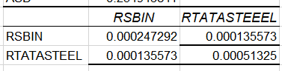

The portfolio returns with equal weights
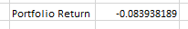

The optimized weights due to the solver :
This was done with maximizing the sharpe ratio while allowing the weights to be changed but the constraint was that the sum of weights should be 1.

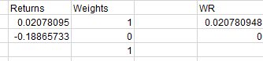

Portfolio returns after optimization
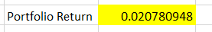

Sharpe ratio with equal weights

Sharpe Ratio with optimal weights

BACKTESTING

The backtesting was done for the weights obtained from the optimization and the closing prices considered were from 13April 2023 to 13 April 2024.

The backtesting proved that our optimization was right as our returns have improved and even the sharpe ratio has improved.
Portfolio Returns from backtesting on next year data:

Sharpe Ratio with Back testing

We have observed that with equal weights our sharpe ratio is the lowest and henceforth giving worse returns and when we optimize our weight we see that the annualized returns on TATASTEEL COMPANY is -ve, thereby the solver has optimized the weights as to fully invest in SBI.

INTERNATIONAL AND DOMESTIC INDICES

1.S&P 500
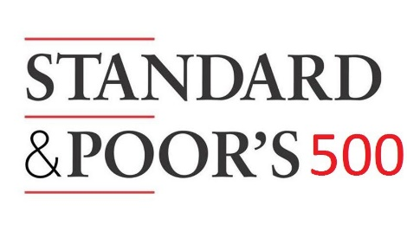
The Standard and Poor's 500, or simply the S&P 500, is a stock market index tracking the stock performance of 500 of the largest companies listed on stock exchanges in the United States. It is one of the most commonly followed equity indices. The S&P 500, short for Standard & Poor's 500, is a stock market index that tracks the performance of 500 large-cap publicly traded companies listed on stock exchanges in the United States
The index is weighted by market capitalization, meaning that companies with higher market values have a greater impact on the index's performance. This weighting scheme reflects the relative importance of each company within the index. Some of the largest and most influential companies in the world are included in the S&P 500, including tech giants like Apple, Microsoft, and Amazon, as well as financial institutions like JPMorgan Chase and Berkshire Hathaway.

2.NIFTY50



The Nifty 50 is a stock market index that represents the performance of the 50 largest and most liquid Indian companies listed on the National Stock Exchange (NSE). The Nifty 50 comprises companies from various sectors such as banking, financial services, information technology, consumer goods, and energy. Similar to the S&P 500, the Nifty 50 is a market capitalization-weighted index, meaning that companies with higher market values have a greater influence on the index's performance.
Overall, the Nifty 50 plays a vital role in the Indian financial landscape, providing investors with a benchmark to gauge the performance of the Indian stock market and serving as a reference point for investment decisions in Indian equities.

OBSERVATIONS FOR THE PORTFOLIO

The historical data was obtained from yahoo finance and for forming the optimized weights portfolio we considered closing prices from 13 April 2022 to 13 April 2023 for both NIFTY50 and S&P500

We start off with equal weights for both the indices

THE VARIANCE – COVARIANCE MATRIX:
This was obtained by using the data analysis add-in in Excel and we get the self variance and co-variance matric of the data taken from yahoo finance.
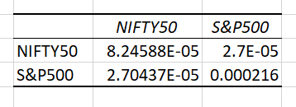

The Optimized weights by the solver :
This was done with maximizing the sharpe ratio while allowing the weights to be changed but the constraint was that the sum of weights should be 1.
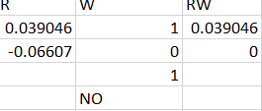

Portfolio returns when equal weights
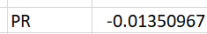

Portfolio returns with optimized weights
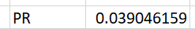

The risk of the protfolio is given by the standard deviation

Sharpe Ratio with Equal weights:

Sharpe Ratio with Optimal weights:

BACKTESTING

The backtesting was done for the weights obtained from the optimization and the closing prices considered were from 13April 2023 to 13 April 2024.

The backtesting proved that our optimization was right as our returns have improved and even the sharpe ratio has improved.

Portfolio returns while backtesting
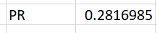

Sharpe Ratio while Backtesting:

We observe that S&P500 has negative returns from its historical data, Thereby the solver has optimized the weights again to adjust for maximizing the sharpe ratio which is to fully invest only in NIFTY50.

CONCLUSION

From the above two portfolios and their optimizations we see that the optimized portfolios have yielded better returns and also have better sharpe ratio and lesser standard deviation.

We also see that the domestic stocks optimized portfolio (SBIN.NS and TATASTEEL.NS) has given better returns than the international Index (S&P 500) return and the domestic index (NIFTY50) during the test period (2022-2023) and also during the backtesting period (2023-2024). This can be seen in the images below :

Stocks portfolio backtesting returns
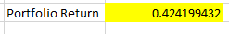

And Annualized returns of S&P 500 and NIFTY50 during backtesting
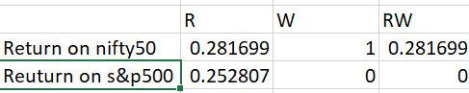

This says that the domestic stocks portfolio has outperformed the international market index. And also the selected optimized portfolio has outperformed the domestic market as well.

